**Experiment Title 2.3**

**Student Name: Sahul Kumar Parida UID: 20BCS4919**

**Branch: CSE Section/Group: WM-904/B**

**Semester: 5th**

**Subject Name: Project Based Learning using Java**

**Subject Code: 20CSP-321**

**1. Aim/Overview of the practical:**

Write a Program to perform the basic operations like insert, delete, display and search in list. List contains

String object items where these operations are to be performed.

**2. Software/Hardware Requirements:**

# Windows

# BlueJ (Java IDE)

# JRE (Java Runtime Environment)

**3. Steps for experiment/practical/Code:**

import java.util.*;

class Worksheet

{

public static int search(ArrayList<String> items, String name)

{

for (int i = 0; i < items.size(); i++)

{

if (items.get(i) == name)

{

return i;

}

}

return -1;

}

public static void Main(String[] args)

{

Scanner sc=new Scanner(System.in);

String name;

int index;

int ch = -1;

ArrayList<String> items = new ArrayList<>();

while (ch != 5)

{

System.out.println("1. Insert");

System.out.println("2. Search");

System.out.println("3. Delete");

System.out.println("4. Display");

System.out.println("5. Exit");

System.out.println("Enter your choice: ");

ch = sc.nextInt();

switch (ch)

{

case 1:

System.out.println("Enter the item to be inserted: ");

name = sc.nextLine();

items.add(name);

System.out.println("Inserted successfully");

break;

case 2:

System.out.println("Enter the item to search: ");

name = sc.nextLine();

index = search(items, name);

if (index == -1)

{

System.out.println("Item not found in the list.");

}

else

{

System.out.println("Item found in the list...");

}

break;

case 3:

System.out.println("Enter the item to delete: ");

name = sc.nextLine();

index = search(items, name);

if (index == -1)

{

System.out.println("Item not found in the list.");

}

else

{

items.remove(index);

System.out.println("Deleted successfully.");

}

break;

case 4:

System.out.println("The Items in the list are: ");

for (int i = 0; i < items.size(); i++)

{

System.out.println(items.get(i));

}

break;

case 5:

//exit

break;

}

}

}

}

**4. Result/Output/Writing Summary:**

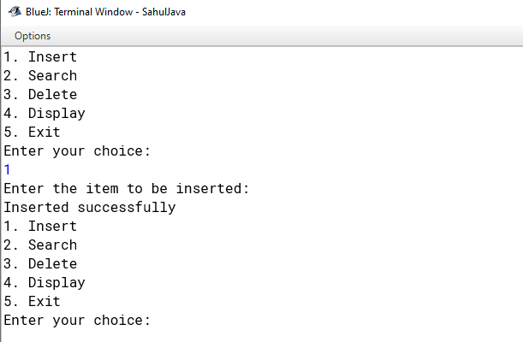

**Learning outcomes (What I have learnt):**

**1. Java Classes**

**2. Java Switch Case Statements**

**3. Arrays, Strings and ArrayLists**

**4. Java If-Else Statements**